A SEMESTER V
CAPSTONE PROJECT PLANNING REPORT ON [B12]
“NAME OF PROJECT” [B16]

SUBMITTED BY [12]
- STUDENT NAME Roll No.
- STUDENT NAME Roll No.

- STUDENT NAME Roll No.
- STUDENT NAME Roll No. [14]
UNDER THE GUIDANCE OF [14]

Mr. XXXX [14]
DEPARTMENT OF MECHANICAL ENGINEERING [14]

Shanti Education Society’s [12]

A. G. PATIL POLYTECHNIC INSTITUTE, SOLAPUR. [B20]
NBA Accredited programs
2022-23. [B16
Shanti Education Society’s [12]
A. G. PATIL POLYTECHNIC INSTITUTE, SOLAPUR [B16]

CERTIFICATE [B18]

This is to certify that

Roll No. | Enrollment No. | Name
Roll No. | Enrollment No. | Name
Roll No. | Enrollment No. | Name
Roll No. | Enrollment No. | Name

from A.G. Patil Polytechnic Institute, Solapur has completed Semester V Capstone Project Planning Report having title…………………………………………………………….. in group consisting of ….. persons under the guidance of the faculty guide the academic year 2024-2025.

Mr. ……………. Mr [14]
(Guide) [12] (H.O.D. Mech. Engg. Dept.) [12]

Mr. ……………. Dr. Chougule M. A. [14] Mentor from industry (if applicable) (PRINCIPAL) [12] Telephone:…………………….

Sequence of pages for Project Report
TITLE PAGE CERTIFICATE
- ACKNOWLEDGEMENT
- ABSTRACT
- RATIONALE
- CONTENTS
- LIST OF FIGURE
- LIST OF TABLE
- NOMENCLATURE
  - CHAPTER 1: Introduction & Background of The Industry or User Based Problem
  - CHAPTER 2: Literature Survey for Problem Identification & Specification.
  - CHAPTER 3: Proposed Detailed Methodology of Solving The Identified Problem with Action Plan with Probable Dates of Completion.
  - CHAPTER 4: In case some prototype has to be fabricated, then its tentative design & procedure for making it.
    - Resources & Consumable Required.
    - References & Bibliography.
IMPORTANT NOTE: Above Mentioned Chapter Names may vary as per different departments however students have to maintain a smooth flow of data in entire semester V project report.

General Guidelines for Project & Seminar Report:
  - Font size for all Text 12, Sub-heading 14, Heading 16.
  - Font should be Times New Roman.
  - Line spacing should be 1.5
  - All text must be justified. (Select all text and press Ctrl+J).
  - Margins Top-1”, Left-1.5”, Right-1”, Bottom-1”. (Page layout→Margins
→Custom margins)
  - Page numbers must be given at the center bottom.
  - Figures and tables should be indicated as below.
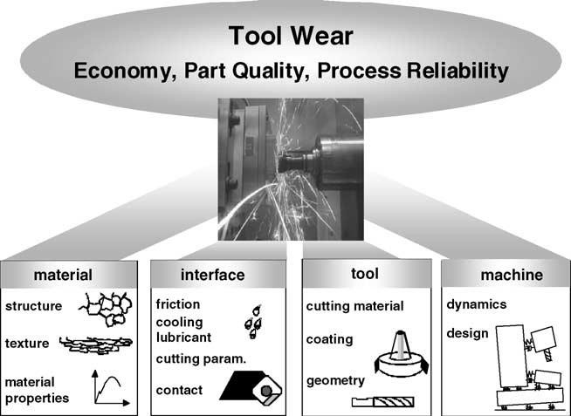

Fig.1.2: Four major functional elements influencing tool wear in machining processes. [Name of figures should be at bottom & bold]

Table 3.1: Experimental result [Name of tables should be at top & bold]

Cutting speed M/min | Shear stress (MPa) | Shear strain
60 | 959.08 | 1.652

- Student should prepare Power Point Presentation (PPT).
- Title page and certificate page should NOT have page no.
- Next 6 pages (highlighted below) should have roman page nos. (i, ii …..)
- Entire project report should have English page nos. (1, 2…….)
- References should not have chapter no. (Shown below at the end)
- Students doing sponsored projects should attach Certificate issued by company.

